**EEA: Environment of Evolutionary Adaptedness**

* During the Miocene
  + In the African tropics
* Total rainfall declined
  + Became more seasonal
* Moist tropical forests shrank and drier environments expanded
* Earliest **hominins** were among the pioneers that survived this period of natural selection
  + Bipedal ape is a hominin

**Hominin Origins**

* From Hominid (Apes) to *Hominin*
  + Ardipithecus ramidus
  + Sahelanthropus Tchadensis
  + Orrorin tugenensis
* Two distinction from Miocene apes
  + Bipedal
  + Different chewing apparatus/skull

**Hominin radiation**

* Fossil apes characteristics
  + Larger brain
  + Extended growth period
  + Knuckle walking
  + Brachiator traits
  + Smaller canines
* Hominins differ
  + Even larger brain/body size
  + Even more extended growth period
  + Habitual bipedality
  + Even more derived dentition and associated jaw/skull muscle

**What makes a human?**

* Habitual obligate bipedal locomotion
  + Began to appear 7-6 MYA
  + **Australopithecines** show these traits (4 to 2 MYA)
* Derived dentition and jaw musculature
* Larger brains in relation to our body size
  + Neanderthals had larger brains than humans do
  + Began to appear in the genus **Homo** around 2 MYA
* Slower development
  + Sexual maturation, end of mating career
* Language and culture
  + Symbolism
  + Grammatical structure
  + Speech; making unique sounds
  + Around 200,000 years ago

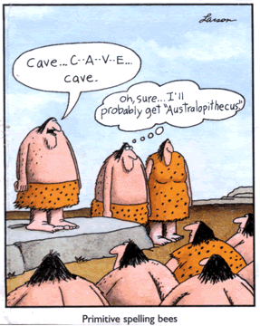

**Human Characteristics**

* **Challenge** for bipedalism: balance
* **Solutions** involve structural changes
* Skull
  + Foramen magnum position and nuchal plane

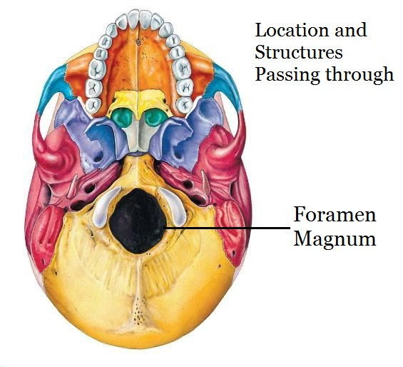

* + Hole at the base of the skull where the spinal cord and brain meet
  + Positioning of the foramen magnum is important for weight distribution
  + Humans have a nuchal plane that is parallel with the ground
* Spine/vertebral column: new curvatures
* Pelvis: shorter, broader to support weight alternating b/w legs

**Chimp**

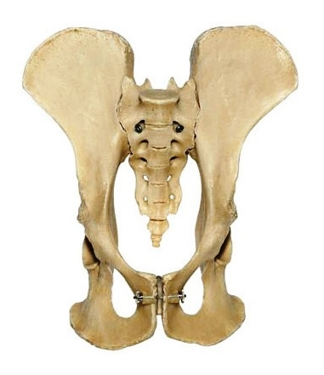

**Human**

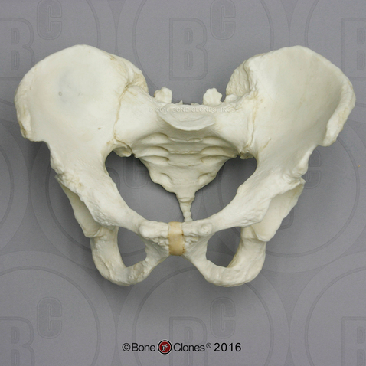

* Leg: angled femur, enlarged femur bottoms and tibia tops, longer legs and big gluteal muscles
* Foot: tarsals/heel, metatarsals

**Benefits of bipedalism**

* **Selection pressure:** role of changing environments
* Feeding posture for branches from ground
* Can carry more tools, resources
  + Paternal investment displayed by carrying provisions to base camp and intersex-selected for
* Face-to-face sex and signaling sex, dominance displays for intrasex competition
* Fighting, punching
  + Intrasex selection, war
* Throwing: hunting and fighting
* Travel benefit on ground, seeing over grass for predator and resources
* Persistence hunting and efficient long distance travel
* Energy efficiency
  + Locomotion
  + Breathing, blood oxygen circulation
  + Cooling: upright posture, blood circulation, sweat